Exercise 1

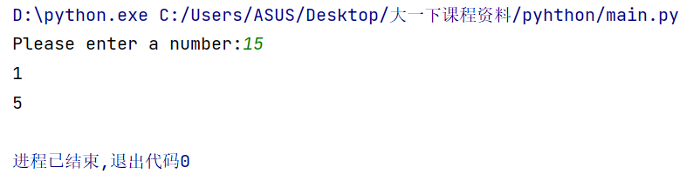

Exercise 2

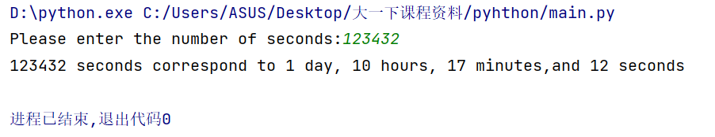

Exercise 3

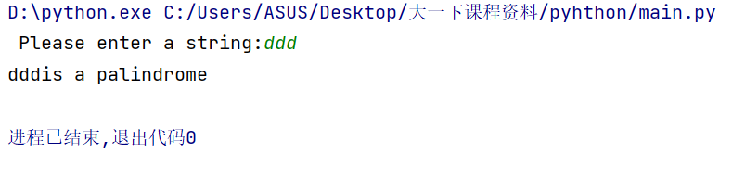

Exercise 4

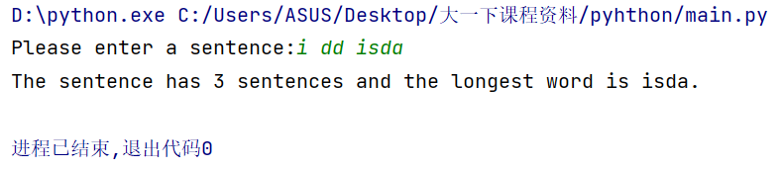

Exercise 5.1

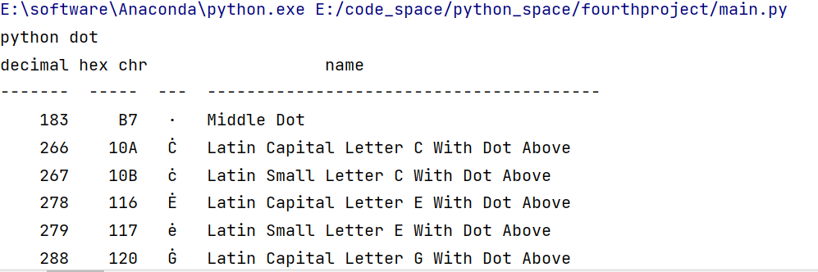

Exercise 5.2

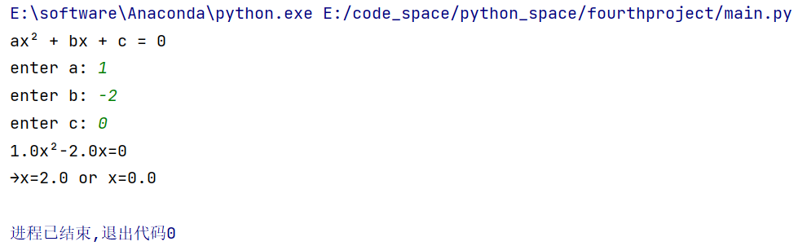

Exercise 5.3

